“Data-driven prioritization of independent fostering agency inspections” project is interested in terms of using fostering agencies’ data to prioritize support for those agencies in most need. In the regular situation. ofsted is an office that regulates and inspects services that provided to children by fostering agencies. Due to lack of resources, it takes ofsted 3 years to inspect all agencies. This project built a model using 10 years data including past inspections, notification from foster agencies, survey, management. This model produces prioritize list of agencies to inspect first. The result was the model helped ofsted to discover 19 agencies that do not meet the requirements and 9 more that need support compared with only 10 agencies without using the model.

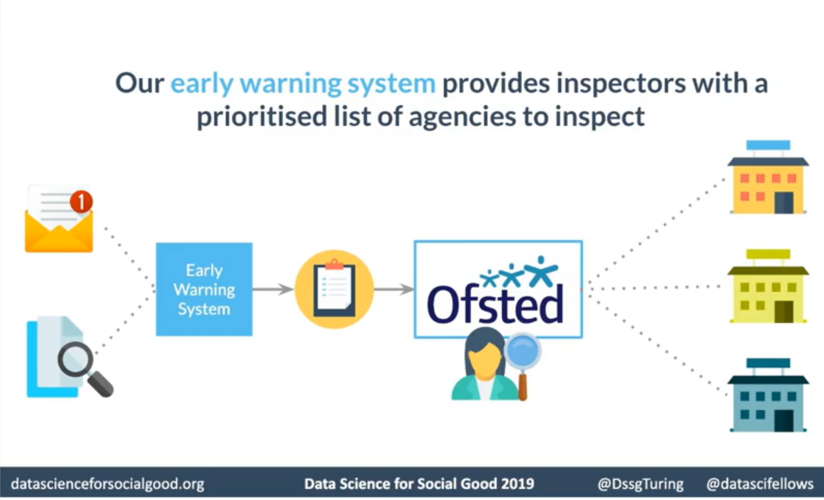

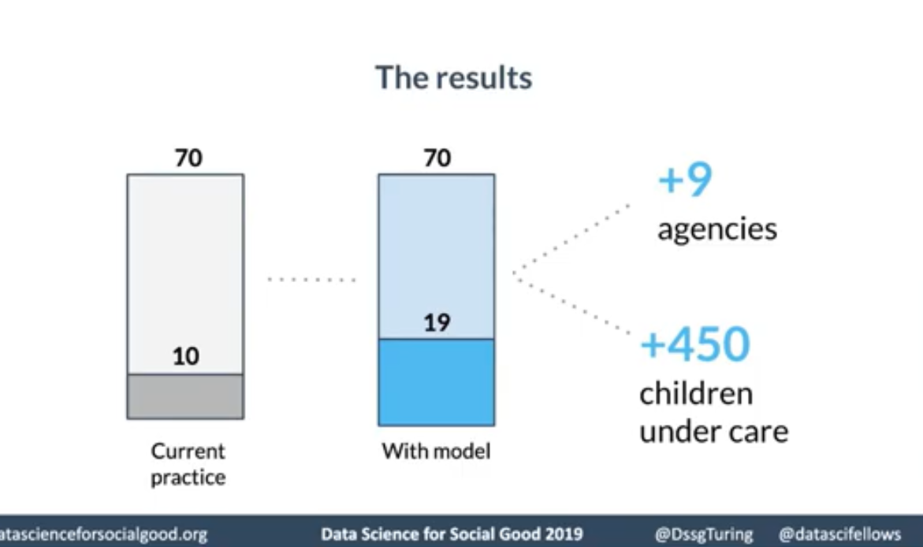

This project could be taken further to be used and improve other inspection agencies such as health inspections or prioritize reservation systems to put who in needs first.

Reference:

https://www.dssgfellowship.org/project/foster-agencies-inspection/